**Static Website Hosting Using S3**

1. First of all log in your AWS account and Go to AWS management console and search for S3.

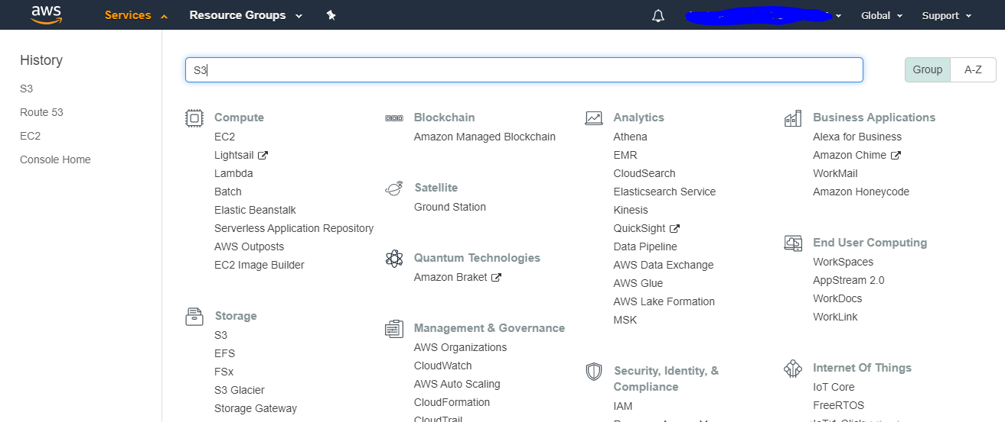

1. You will be directed to s3 management console. Here click on create bucket

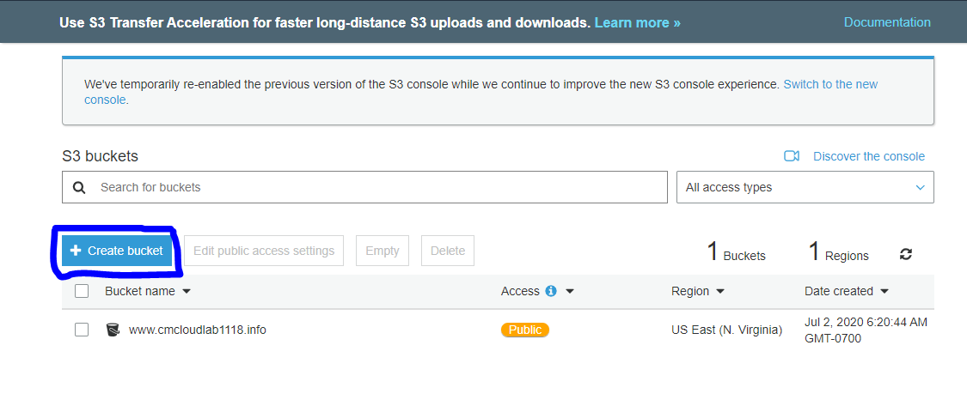

1. You will the following pop up box.

* You need to give the name for your bucket. Bucket name should be the name of domain that you have.
* Add tag. Most commonly used Tag is “ name “ and value could be any data for that tag.
* Then left remaining setting default and click on create bucket.

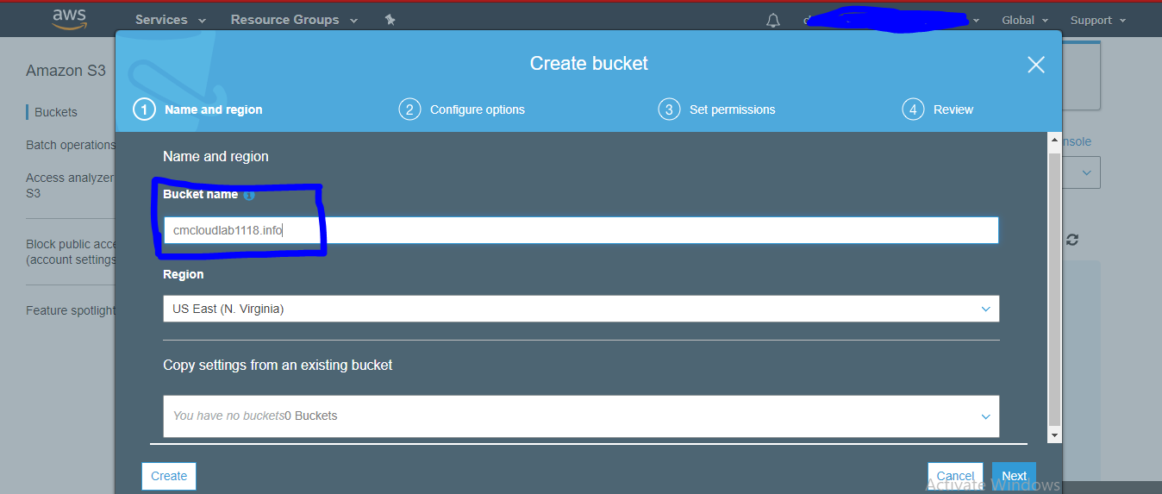

1. Your bucket has been created. Now we will upload our static website to S3. Just click on bucket name and click on upload.

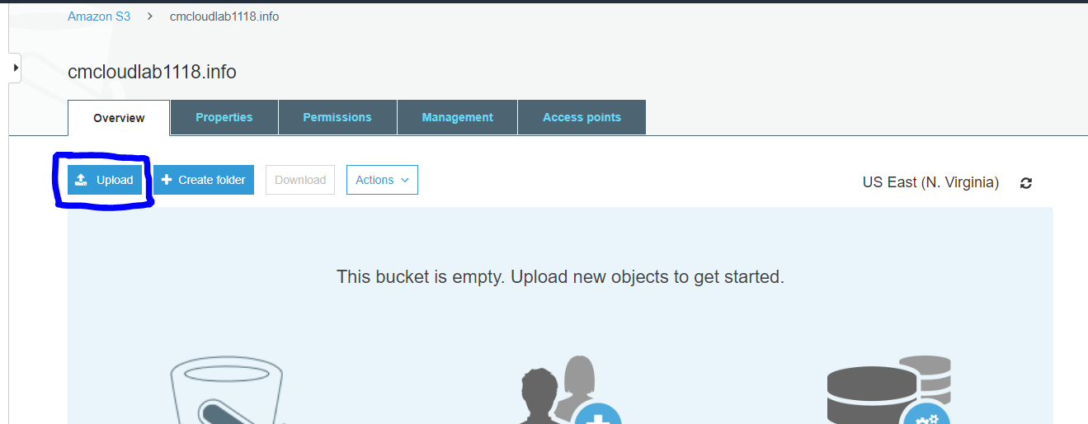

1. Select all your files and then drag and drop to console. Click on next, next and then upload. Your files will be uploaded.

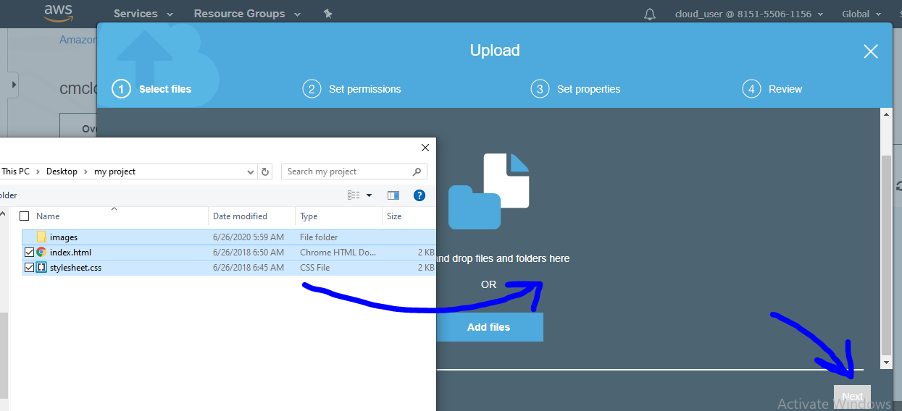

1. Then if you try to access your bucket through browser using URL. You would be unable to do that.we need to all public access to access bucket globally. Go to permissions and uncheck the box which says block all public access.

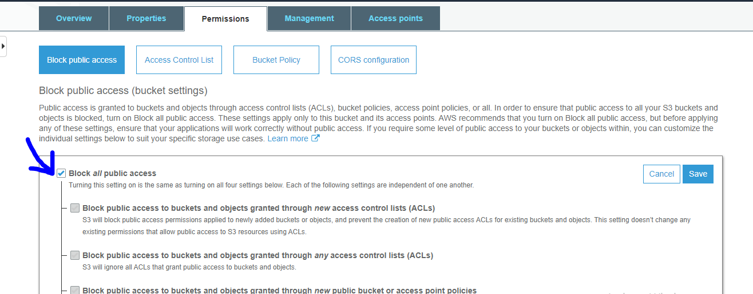

1. Now let’s create a bucket policy to set overall permissions for our bucket. For that go to permissions, and use online policy generator.

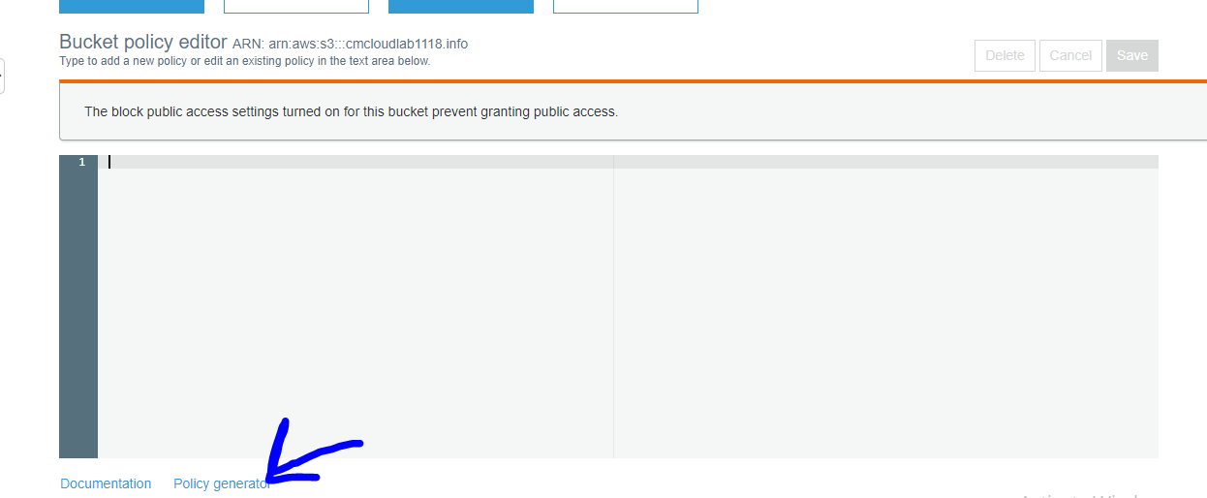

1. Set all properties , add statement and then click on generate policy. Copy that and paste it on place and click on save.

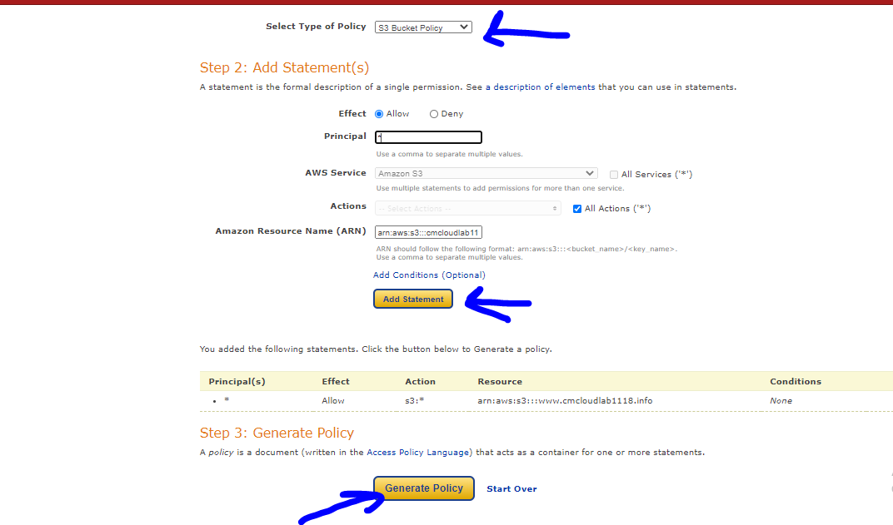

1. Then after that under properties we need to set property set this bucket to host static website. Give the name of your landing page like index.html and then click on save.

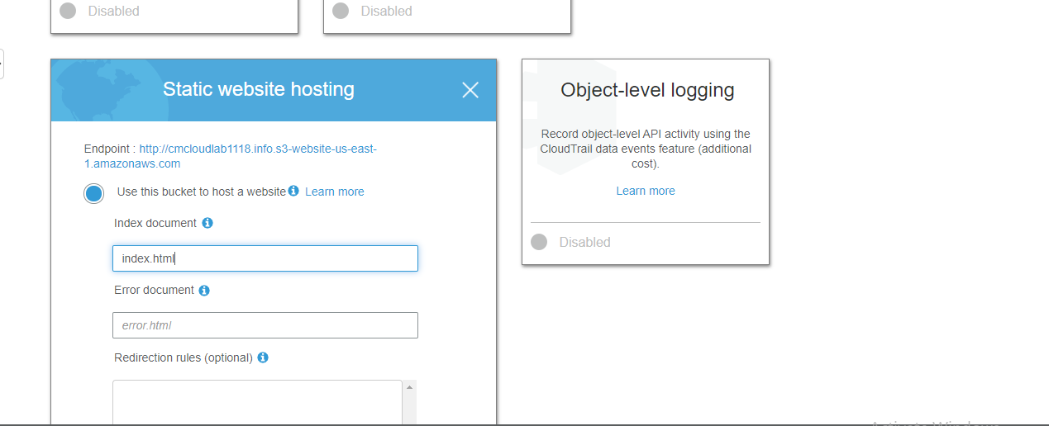

1. Then finally we have all set with website hosting now we need to add our custom domain with our website.

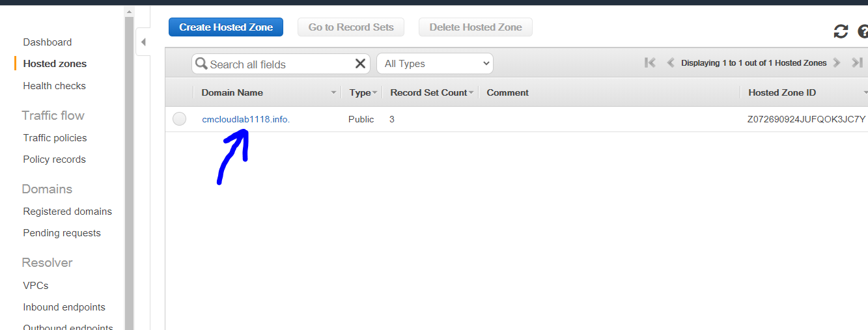

1. Click on this domain and create record set it is provided by AWS and then click on Alias as yes and select s3 from dropdown and then save.

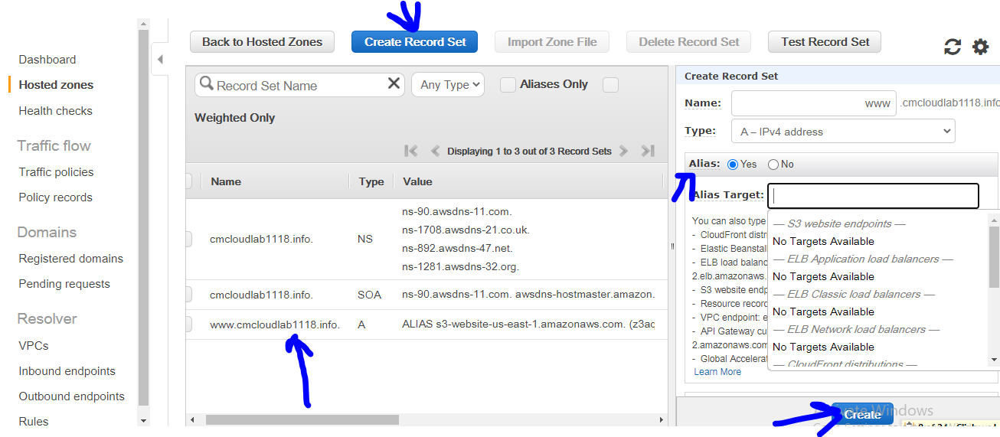

1. Hit below URL in browser and you will be able to access your website.

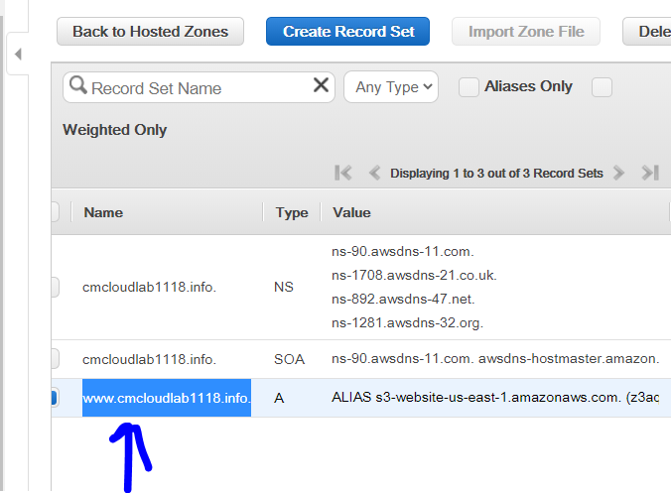

**Hurrah! Congratulations we have done with our task…….!!!!!!!!**